Complaint Policy and Procedure

Policy Statement
Intec Business Colleges are committed to providing the highest standard of service. We welcome all feedback from learners, employers and partner organisation including compliments, complaints and any issues affecting service delivery. Should you experience issues affecting service then we will seek to address these as quickly as possible. We aim to ensure that:
- Making a complaint is as easy as possible for you.
- Complaints are treated seriously regardless of how they are received.
- A complaint is dealt with promptly, politely and, where appropriate by telephone.
- We respond with a full explanation and information on any action taken.
- All complaints are treated with the level of discretion and sensitivity they deserve.
- We learn from complaints by establishing the root cause and take any appropriate action to improve our service and your experience going forward. The mechanism for this is the organisations Curriculum Group, Senior Team and Governance Team.
A complaint is defined as being any dissatisfaction with service or quality of provision. This policy applies to both employers and learners.
Policy & Procedure Review
This policy is reviewed annually by the Senior Management Team.
Policy last reviewed: March 2023
Next Review date: March 2024

Raising a complaint
Detailed below is Intec’s procedure for dealing with complaints from learners, employers and partners. We provide the details of their key point of contact within Intec (Tutor/Delivery Manager or Account Manager) and in the first instance please make contact with that individual. Should this fail to provide you with a satisfactory resolution, or you feel it is inappropriate to address your complaint to the individual, then please make contact via one of the following options:
E: Intec@intecbusinesscolleges.co.uk
T: 01788 575090
Write to: Old School, Pennington Court, Rugby, CV21 2BB
Your contact will be acknowledged within 24 hours and you will be contacted directly by the appropriate individual as set out in the flow chart below.
Signed
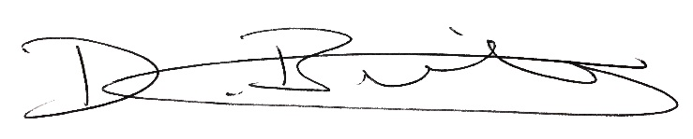

Darren Bunting | Managing Director
Complaint
Resolved
Complaint referred to:
- Quality Issues: Awarding body/End Point Assessment Organisation/Ofsted
- ESFA: T: 08000 150 600
E: helpdesk@manage-apprenticeships.service.gov.uk
- Service/Other Issue: English Law

Acknowledgement within one week

No Agreement
Complaint referred to:
- Quality Issues: Managing Director
- Service Issues: National Sales Director
- Other Issues: Managing Director

Acknowledgement within 24 hours
Complaint
Resolved
Complaint
Resolved
Complaint
Resolved
Agreement reached within one month

Agreement reached within two weeks

Agreement reached within one week

No Agreement
Learner communicates complaint to Operations Manager providing information/details of the nature of the complaint.
Employer/Partner communicates complaint to Account Manager.

Acknowledgement within 24 hours

Acknowledged within 24hours
No Agreement
Learner complaint: Learner communicates complaint to Intec first point of contact (Tutor or Delivery Manager).

Acknowledgement within 24 hours

Acknowledgement within 24hours.

